LAB SESSION: 06
(Queue Implementation Using Arrays)

Class For Queue
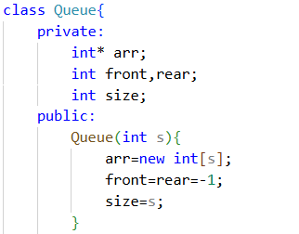

- Modify the code to allow user input for enqueue and dequeue operations.
CODE:

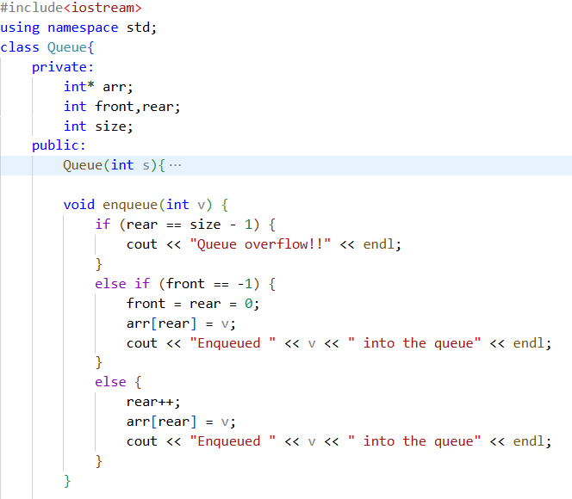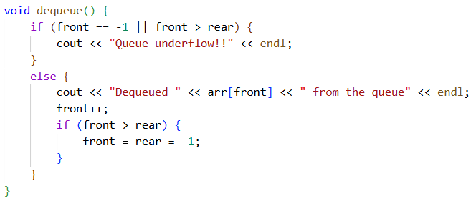
int main()
{
int size;
cout << "Enter queue size: ";
cin >> size;
Queue q(size);
int choice, value;
do {
cout << "************** Queue Menu ***********"<<endl;
cout << "1. Enqueue"<<endl;
cout << "2. Dequeue"<<endl;
cout << "3. Exit"<<endl;
cout << "**************************************"<<endl;
cout << "Enter your choice: ";
cin >> choice;

switch (choice) {
case 1:
cout << "Enter value to enqueue: ";
cin >> value;
q.enqueue(value);
break;
case 2:
q.dequeue();
break;
case 3:
cout << "Exiting program..."<<endl;
break;
default:
cout << "Invalid choice! Please try again"<<endl;
}
} while (choice != 3);

}

Output:
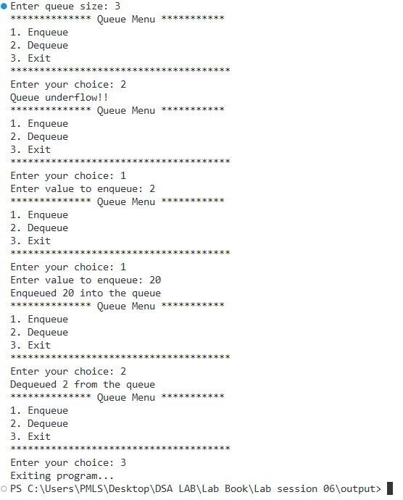

- Implement a peek() function to return the front element without removal.
CODE:
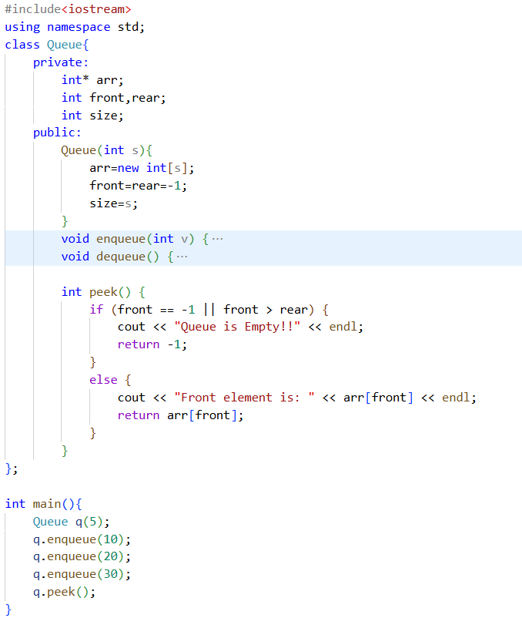}

OUTPUT:
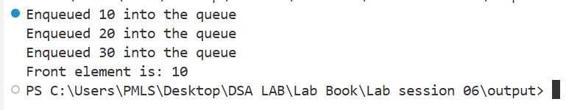
- Write a function to check if the queue is full or empty.
CODE:
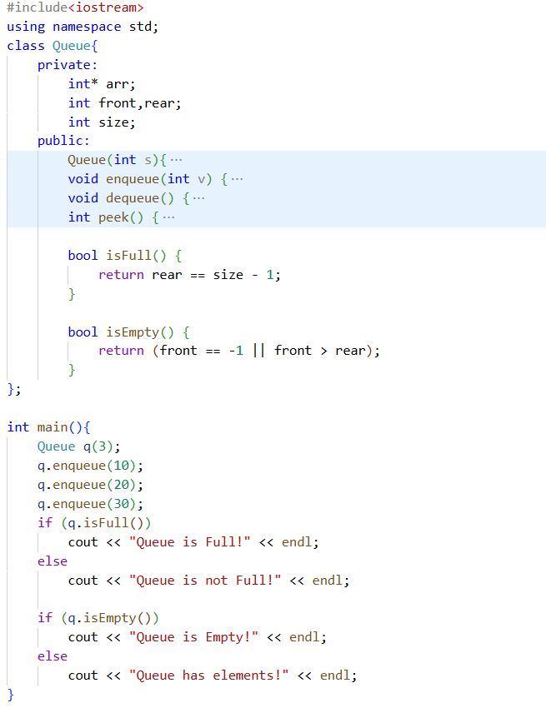

OUTPUT
